For WKSP DSS 220, we will be using Anaconda, which is an open source distribution platform for Python. It will be your primary source for installing various Python libraries, and the package comes with several tools that we will use, especially Jupyter Notebooks.

Python is approved for installation on a government computer. You will need to work with your computer help desk to get that scheduled. Alternately, you can work on your personal computer.

# Installation

To install Anaconda, go to <https://www.anaconda.com/products/distribution> and click on the button labelled download:

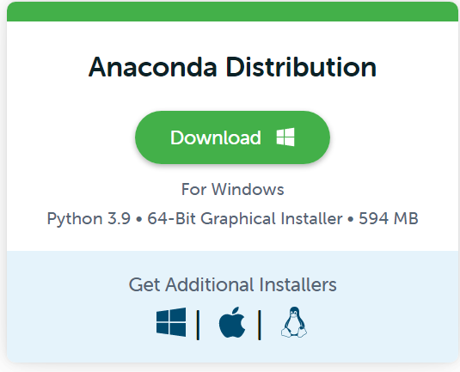

There is a download version for Apple and Linux computers as well. Follow the installation instructions on your screen. For further detail, see documentation here: <https://docs.anaconda.com/anaconda/install/index.html>

# First Use

Once installed, you will have a folder on your start menu for Anaconda:

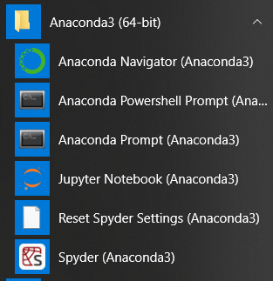

Open the Anaconda Prompt. Next we will install several python packages that we will use in this course. **Note:** on government computers, your computer help desk may need to do this.

**Note:** you may need admin privileges for this next step. Type the following to install one package at a time:

* conda install numpy=1.21.5
* conda install pandas=1.4.4
* conda install matplotlib=3.5.2
* conda install seaborn=0.11.2
* conda install scikit-learn=1.0.2

# Jupyter Notebook

After installing the libraries, open your first Jupyter Notebook. First, open the Anaconda prompt like we did above. Next type in **Jupyter Notebook** in the command line. A browser window should open.

Click on the **New** drop down on the right and then click **Python 3 (ipykernel)**

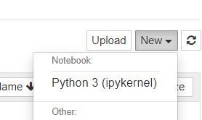

This will open a blank Jupyter Notebook. There type **print("hello world!")** and press **Ctrl+Enter** or Play/Run button along the top ribbon

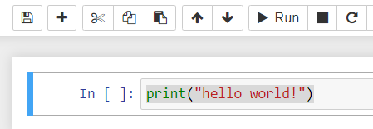

Below your line you will see the text **hello world!** printed.

To open a notebook from the course, click on File --> Open, and then navigate to the file on your computer.

Jupyter Notebooks allow you to run Python code one or more lines at a time. They also let you insert text lines in between code sections so the author can explain different parts of the code. For a good primer on how to creatively edit text, see this tutorial: [Format Text In Jupyter Notebook With Markdown | Earth Data Science - Earth Lab](https://www.earthdatascience.org/courses/intro-to-earth-data-science/file-formats/use-text-files/format-text-with-markdown-jupyter-notebook/)

# Anaconda Cloud

If you do not have a personal computer, you can code online by creating an Anaconda Cloud account. You have to create an account on <https://anaconda.cloud/>. Then click on “launch notebook”. You will need to create a folder for the class, and all of the subfolders (Module 1-4), and then copy and paste each of the module files into each subfolder. Remember to also copy over the class library file *Wksp722_functions.py* into your main class folder. This website is accessible through the AFNET so you can code on your work computers. Remember that this is only approved for unclassified publicly approved data and files only.

# Kaggle.com

As an alternative to installing on your computer, you can work directly on Python coding through a web browser from Kaggle.com. You will need to create an account. After that, the website provides a way to create a new Python notebook which is very similar to Jupyter Notebook and will serve for the lessons taught in this course. This approach will not require installing any software and can be accessed on a government computer. I will have a small lecture introducing the website and its uses.